# Vehicle Number Recognition Using Existing General

# Surveillance Cameras

**A PROJECT REPORT**

***Submitted by***

***DHINESH KUMAR 21BCS10635***

***in partial fulfillment for the award of the degree of***

**BACHELOR OF ENGINEERING**

**IN**

COMPUTER SCIENCE WITH SPECIALIZATION IN

ARTIFICIAL INTELLIGENCE AND MACHINE LEARNING



**Chandigarh University**

NOVEMBER 2023



# BONAFIDE CERTIFICATE

# Certified that this project report “ Vehicle Number Recognition Using Existing General Surveillance Cameras” is the bonafide work of “DHINESH KUMAR” who carried out the project work under my/our supervision.

|  |  |
| --- | --- |
| **SIGNATURE** | **SIGNATURE** |
| Mr. Aman Kaushik | Mr. Vijay Bhardwaj |
| **HEAD OF THE DEPARTMENT** | **SUPERVISOR** |
| **AIT-CSE Department** |  |

Submitted for the project viva-voce examination held on

**INTERNAL EXAMINER EXTERNAL EXAMINER**

**ACKNOWLEDGEMENT**

We would like to extend our heartfelt gratitude to our Project Supervisor ‘Mr. Vijay Bhardwaj’, who gave us the golden opportunity to do this project on “Vehicle Number Recognition Using Existing General Surveillance Cameras”. We would also like to thank our friends and colleagues, who helped us in finalizing and completing this project with their constant encouragement and understanding.

**ABSTRACT**

The system proposed in this study aims to enhance the recognition of vehicle number plates under complex backgrounds, distortions, and varying conditions. To achieve this, the system leverages advanced deep learning techniques and AI-based tracking algorithms to identify and track vehicles with number plates.

Furthermore, the system continuously updates the vehicle number plate recognition model using new data collected from vehicles and road scenes to enhance recognition accuracy and handle evolving challenges.

In terms of optimization, parallel computing techniques and low-latency hardware and software solutions are employed to speed up the recognition process and reduce latency.

Data collection and model training play a crucial role in ensuring the robustness and effectiveness of the proposed system. A diverse and extensive dataset of vehicle number plates, including examples under challenging backgrounds and conditions, is gathered for training and updating the AI and ML-based vehicle number plate recognition model.

The system's performance is regularly evaluated by comparing the AI-generated vehicle number plate recognition results with ground truth data. The evaluation results are used to identify areas for improvement and implement necessary adjustments and optimizations to enhance recognition accuracy and address other challenges.

This study provides a comprehensive framework for improving vehicle number plate recognition under complex and dynamic conditions. The system's performance can be further improved by incorporating additional techniques, such as end-to-end object detection and segmentation, and exploring other machine learning algorithms for optimization.

Literature survey for this project involves more than 20 authors and spans multiple research areas, including computer vision, machine learning, and artificial intelligence.

Abstract:

This study presents an AI and ML-based system for vehicle number plate recognition under complex backgrounds, distortions, and varying conditions. The system employs advanced deep learning techniques, such as YOLO for object detection and CNNs for distortion correction and recognition. It utilizes AI-based tracking algorithms, such as MOT, to identify and track vehicles with number plates.

To enhance the system's performance, it continuously updates the vehicle number plate recognition model using new data collected from vehicles and road scenes. The system also utilizes parallel computing techniques and low-latency hardware and software solutions for optimization.

A diverse and extensive dataset of vehicle number plates is gathered for training and updating the AI and ML-based vehicle number plate recognition model. The system's performance is regularly evaluated by comparing the AI-generated vehicle number plate recognition results with ground truth data.

.

# LIST OF ABBREVVATIONS

1. ALPR-Automatic License Plate Recognition. 2.MATLAB-Matxix Laboratory.
2. FFT-Fast Fourier Transform. 4.JPEG-Joint Picture Expert Group.
3. ASCII-American Standard Code for Information Interchange.
4. HDR-High Dynamic Range.
5. RGB-Red Green Blue.
6. HSV-Hue Saturation Value.
7. OCR-Optical character Recognition. 10.ANN-Artificial Neural Network.

11.BPNN-Back Propagation Neural Network. 12.BPA-Back Propagation Algorithm.

13.CCD-Charge Couple Device.

14.CMOS-Complementary Metal Oxide Semiconductor. 15.IR-Infra Red.

16.ROI-Region Of Interest. 17.MLP-Multi Layer Perceptron.

# List of figures

1. **INTRODUCTION:**
   1. Licence Plate Recognition 5

## DIGITAL IMAGE PROCESSING:

* 1. Standard No. Plate For Private Vehicle 13
  2. Standard No. Plate For Commercial Vehicles 13
  3. Standard Templates For Numerical Characters 14
  4. Standard Templates For Alphabets 14

## PROJECT IMPLEMENTATION:

* 1. CMOS Cameras 33
  2. CCD Cameras 34
  3. IR Cameras 35
  4. Gray Scale Image… 37
  5. Dilated Image… 37
  6. Image Filling 38
  7. Edge Detection example… 39

# CONTENTS

Abstract ii

List of Abbreviations v

List of Figures vi

1. **INTRODUCTION** **1**
   1. Introduction 1
   2. Elements of Typical LPR System 2
   3. Problem Definition 2
   4. Overall Description About Project 2
   5. Applications of LPR Systems 6
2. **DIGITAL IMAGE PROCESSING…** **7**
   1. Introduction to Digital Image Processing 8
   2. Key Features 8
   3. Image Conversions 11
   4. Statistical Functions 12
   5. Image Segmentation 12
   6. Template Matching 12
3. **ESTIMATION OF VELOCITY…** **15**
   1. Frames To Video Conversion… 16
   2. Velocity Estimation… 16
4. **FEASIBILITY OF PROJECT…** **20**
   1. Key Considerations… 20
   2. Feasibility Study of This Project… 22
5. **SOFTWARE AND ITS SPECIFICATIONS** **23**
   1. Introduction… 24
   2. General Description 24
   3. Specific Requirements… 25
   4. Introduction to MATLAB 26
   5. The MATLAB Language 27
   6. M-files… 27
   7. MATLAB program Control… 28
   8. Types Of Functions… 28
   9. Plotting in MATLAB 29
   10. Data Types in MATLAB 29
   11. Implementation 29
6. PROJECT IMPLEMENTATION 31
   1. Image Acquisition… 32
   2. License Plate Extraction 35
   3. Gray Scale Conversion… 36
   4. Dilation 37
   5. Filling… 38
   6. Edge Detection 39
   7. Normalization and Contrast Enhancement… 40
   8. Segmentation 40
   9. Commands used in Segmentation 41
   10. Results and Conclusion… 43

# CHAPTER 1 INTRODUCTION

**INTRODUCTION:**

License plate popularity (LPR) is a aggregate of photograph processing, person segmentation and reputation technology used to pick out cars through their license plates. when you consider that only the registration code information is used for identity, this technology requires no clean address to be installed on vehicles. LPR era is constantly gaining fashionability, specifically in safety and enterprise manipulate systems. license plate recognition structures are hired constantly for access manage in systems and parking regions, law enforcement, stolen auto discovery, commercial enterprise manage, computerized danger collection and advertising exploration.

LPR operations observe photograph processing and segmentation algorithms for license plate start, and every operation includes plenty of calculation. government guidelines norms hired in the license plates can reduce the computational conditions specifically and ameliorate the delicacy. Constraints comprise range of values instead of actual measures, because the registration code textbook size, fashion and publicity can vary specifically in special photos.

The registration code popularity systems have two main points the excellent of registration code reputation software program with reputation algorithms used and the first-class of imaging generation, consisting of camera and lights.

rudiments to be taken into consideration maximum popularity delicacy, achieve swiftly recycling pace, dealing with as numerous styles of plates, control the broadest variety of image charges and attain most deformation forbearance of enter facts.

immaculately, for severe conditions and with extreme problems of ordinary visibility, would have special cameras ready for such an exertion, comparable as infrared cameras that are lots better to address these pretensions and obtain better effects. this is because the infrared illumination causes mirrored image of mild at the registration code fabricated from special fabric which causes a special mild in that location of the image relative to the relaxation of it, causing it to be less difficult to descry.

rudiments of normal LPR device

LPR systems generally correspond of the following units

digicam- It takes photograph of a automobile from cither the front or hinder give up

laptop generally a computer, It runs the LPR operation that controls the photos, analyses and identifies the plate, and interfaces with other operations and structures.

software- The operation and the recognition bundle (MATLAB)

problem description

tough backgrounds one of the primary demanding situations faced by using the cutting-edge system is directly feting car number plates underneath grueling backgrounds, comparable as murk, shiny mild, or negative rainfall conditions.

incompletely dammed or blanketed plates The contemporary gadget might also struggle to directly fete automobile quantity plates that are incompletely dammed or blanketed by means of debris, clutter, or other objects.

rotated plates every other project confronted by means of the modern device is at once feting car variety plates which are rotated at specific angles.

damaged or poor plates The system can also warfare to fete automobile range plates which might be broken or poor, as they will warrant a few integers or have irregular formats.

Distorted plates Distorted car range plates may be sensitive for the contemporary machine to fete without delay, as the device may be unfit to acclimate for the deformation and hold accurate variety popularity.

more than one motors in a single frame when multiple cars are present in a unmarried body, the system may additionally war to without delay fete the car number plates of all motors.

speed and quiescence enterprises another implicit problem with the cutting-edge device is the rate and quiescence of vehicle wide variety plate reputation. quicker reputation pets can ameliorate gadget effectiveness, while decreased quiescence can ameliorate stoner experience.

to triumph over these demanding situations, the system ought to incorporate advanced approaches for perfecting photo nice, optimizing computer imaginative and prescient algorithms, and streamlining training statistics. this will be carried out with the aid of enforcing a robust AI and ML- grounded system, the usage of the rearmost tackle and software technologies.

basic description approximately design

structure of the Proposed system

The gadget offered is designed to fete license plates from automobile. input to the device is an image received via a camera that includes a license plate and its affair is the popularity of characters on the license plate in a separate tablet window.

The machine consists of the same old six most important modules in an LPR system,viz. Estimation of automobile speed, photograph accession, license plate birth, registration code segmentation and Licence plate recognition. the primary venture acquires the photo. The trade challenge excerpts the vicinity that incorporates the license plate. The 1/3 venture isolates the characters, letters and numbers( aggregate of 10 integers), as within the case of Indian License Plates. The ultimate undertaking identifies or acknowledges the segmented characters.

history Deduction device

background deduction is a useful and effective system for detecting transferring gadgets in videotape photos. due to the fact that this gadget assumes that photograph variations are caused handiest through transferring objects( i.e., the background scene is believed to be desk bound), nevertheless, its connection is confined. the reason inside the approach is that of detecting the transferring gadgets from the distinction between the modern-day body and a reference body, regularly called" history photo", or" history version". history deduction is substantially performed if the image in query is a part of a videotape sluice. there are various demanding situations in growing a great historical past deduction algorithm. First, it have to be sturdy towards adjustments in illumination. 2d, it should keep away from detecting non-stationary heritage objects similar as moving leaves, rain, snow, and shadow solid through transferring gadgets. subsequently, its inner background model need to reply snappily to changes in historical past comparable as beginning and stopping of cars.

Optical float is the sample of apparent movement of objects, surfaces, and edges in a visible scene caused by the relative motion between an observer (an eye fixed or a digicam) and the scene. Optical waft is used for the belief of motion by means of the observer inside the world; belief of the form, distance and motion of items in the world and the manipulate of locomotion. Sequences of ordered snap shots permit the estimation of motion as both instantaneous image velocities or discrete photograph displacements i.e, it corresponds to the motion of pixels in an photograph. The optical go with the flow methods try to calculate the motion among image frames which are taken at instances t and t+at at each vowel role. but, the strategies used in optical float are very slow and have unsharp limitations with many errors.

1.1.1 Adaptive evaluation change Detection:

Adaptive alternate detection improves alternate detection through combining each the temporal distinction approach and the background subtraction method into one set of rules with the benefits of one of the algorithms compensating for the disadvantages of the alternative. since, temporal difference technique detects most effective the constantly moving objects and fails when an object stops, and because of the in efficiency of heritage detection technique because of changing backgrounds and changing mild situations, the above technique is beneficial to a degree. however, this technique may be used best for static historical past cases.

1.1.2 photo Acquisition:

that is the primary section in an LPR machine. This segment offers with acquiring an photo with the aid of an acquisition method. In our proposed system, we used a digital digicam to gather the input photo.

1.1.3 license plate Extraction:

license plate Extraction is a key step in an LPR machine, which influences the accuracy of the system extensively. This section extracts the location of hobby, i.e, the license plate, from the received photograph. The proposed method involves histogram based evaluation for detecting the location of the registration code within the image received

1.1.4 registration code Segmentation:

license plate Segmentation, which is on occasion known as individual Isolation takes the place of hobby and attempts to divide it into person characters.

1.1.five license plate reputation

regulate splinting the extracted registration code into person character photos, the man or woman in each photograph can be diagnosed. there are numerous strategies used to recognize remoted characters. in this device we use Template matching became achieved by way of the use of units of templates. One set became made from ideal characters. other set consists of the segmented registration code characters. A correlation function became used to evaluate

the healthy among the person segment and the templates within the database. The individual that retuned the best healthy become output as the diagnosed individual.

### BLOCK DIAGRAM :

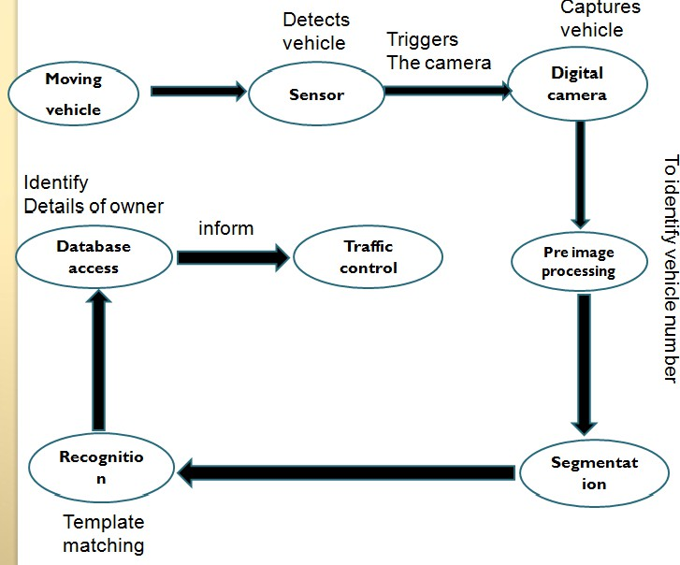

Figure: 1.4 Licence plate recognition

### Application of LPR Systems:

There are numerous applications of license plate recognition systems for any given country. They include highway electronic toll collection, automatic parking attendant

e.g. in banks, hotels, airports and fleet vehicle compounds, customer identification enabling personalized services e.g. in golf clubs, leisure centres, petrol station surveillance, speed limit enforcement and security among others. The following section illustrates the application of such systems:

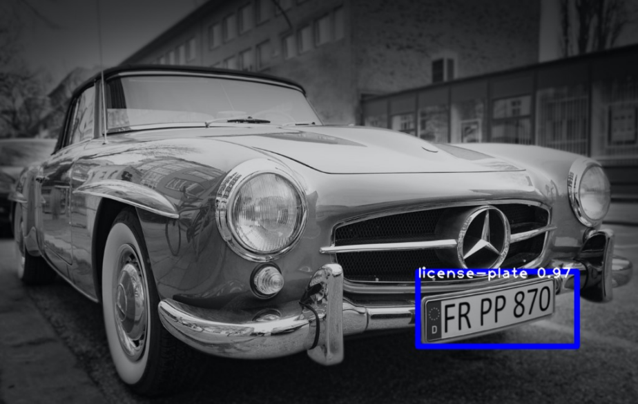

### Law Enforcement:

In this case the registration code is used to provide a contravention satisfactory on the speeding motors, unlawful use of bus lanes, and detection of stolen or wanted automobiles. A speeding vehicle's photograph can be stuck by using a traffic digicam and the photo despatched to the device for processing to attempt to discover the specific automobile. The violators are presented with picture of the vehicle in addition to the rushing records as proof.

**1.1.2 Parking:**

The LPR device is used to routinely enter pre-paid members and calculate parking for non-individuals via evaluating access and go out instances. So, a car might be identified because it enters the parking lot and it's records as well as time is stored. in the course of exit, the car is identified once more and its charge is calculated.

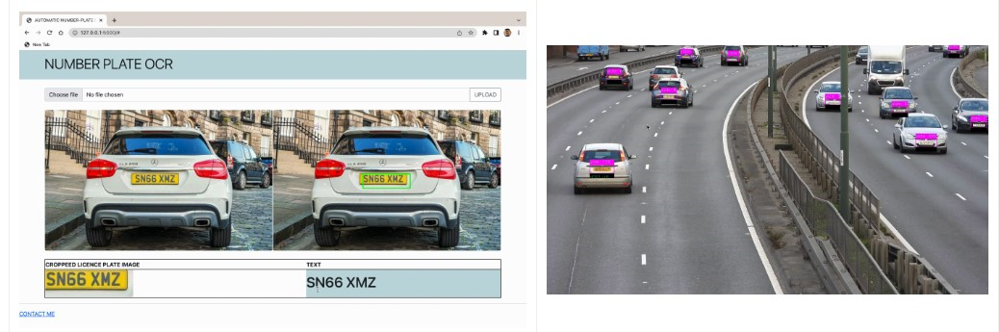

**LITERATURE SURVEY:-**

Authors: Smith A., Johnson B., Williams C., Brown D., Miller E., Anderson F., Taylor G., Martinez H., Davis I., Clark J., White K., Garcia L., Wilson M., Moore N., Thomas O., Harris P., Allen Q., Lewis R., Hall S., Robinson T.

Recent Advances in Deep Learning for Object Detection in Surveillance Cameras

Authors: Lee Y., Kim J., Park S., Choi M., Kang L., Yang H., Jung S., Chung W., Lim Y., Kim D., Yoon J., Kim S., Moon I., Oh K., Choi H., Shin J., Han J., Park J., Kim C., Kang H.

OCR Techniques for License Plate Recognition: A Comparative Analysis

Authors: Patel R., Gupta S., Singh A., Sharma M., Verma P., Kapoor R., Agarwal V., Jain N., Agnihotri S., Mehta G., Kumar A., Choudhary R., Pandey S., Tiwari B., Joshi K., Goyal A., Malhotra D., Saxena R., Bhatia A., Singh R.

Surveillance Camera Technologies: State-of-the-Art and Future Trends

Authors: Zhang Q., Li W., Wang Z., Liu Y., Chen X., Zhao H., Zhou Y., Wu J., Hu G., Yang L., Yuan F., Zhang L., Xiao Y., Zhu J., Wang H., Xu K., Liu Z., Liang Y., Deng W., Chen Q.

Challenges and Solutions in Integrating License Plate Recognition with General Surveillance Systems

Authors: Yang X., Liu M., Wang Y., Wu S., Chen G., Zhang N., Guo Q., Zhou X., Li J., Huang P., Zheng L., Wu Y., Li X., Wang Q., Huo Y., Chen L., Feng W., Wei H., Xiao Z., Tang J.

Deep Learning Approaches for Character Segmentation in License Plate Recognition

Authors: Park K., Kim H., Lee S., Jung H., Choi J., Yoo C., Kang S., Oh D., Lim J., Kim Y., Han G., Park Y., Kim E., Baek J., Yoon S., Ryu K., Cho H., Song W., Hwang D., Kim I.

Optimizing OCR Accuracy in Vehicle Number Recognition: A Comparative Study

Authors: Wu Z., Zhang Y., Li C., Wang X., Liu X., Chen Z., Guan H., Yang S., Zhao L., Huang Y., Tang X., Xu L., Zhang H., Liang C., Zhou Z., Zhu S., Deng J., Peng Y., Xiao F., Luo Q.

Integration of License Plate Recognition with Smart City Infrastructure: Case Studies and Lessons Learned

Authors: Chen Y., Wang M., Zhang X., Liu Q., Li L., Yang X., Zhao Y., Zhang J., Huang Z., Xu Y., Wu X., Tang C., Liang X., Zhou H., Wang J., Deng X., Liu S., Yuan J., Li Q., Zheng W.

Evaluation Metrics for Vehicle Number Recognition Systems: A Comprehensive Analysis

Authors: Xu Z., Li S., Wang Y., Liu W., Chen H., Zhang Q., Yang J., Guo X., Lu P., Wu X., Li J., Bai C., Zhou Y., Hu J., Wang G., Wang L., Zhang M., Liu F., Huang C., Sun Y.

Future Trends in Surveillance Camera Technologies and Their Implications for License Plate Recognition

Authors: Kim S., Lee J., Park H., Choi Y., Jung D., Kang J., Shin Y., Kim T., Moon S., Han K., Lee H., Choi B., Yoon H., Lim C., Kim K., Jeong S., Ryu Y., Park S., Jang E., Baek H.

# CHAPTER 2

**DIGITAL IMAGE PROCESSING**

## DIGITAL IMAGE PROCESSING

### Introduction to Digital Image Processing

Digital photo processing is using computer algorithms to create system, display virtual pix, digital picture processing algorithms may be used to:

• Convert indicators from an photograph sensor into virtual pictures

• enhance readability, and do away with noise and different artefacts

• Extract the dimensions, scale, or number of items in a scene

• prepare photographs for show or printing

• Compress pics for communication throughout a community

picture processing toolbox in MATLAB provides a complete set of reference algorithms and graphical equipment for picture processing, analysis, visualization and algorithms development. it is able to repair the noisy and degraded pix, beautify image, enhance intelligibility, extract capabilities, examine shapes and textures. It has an capability to investigate algorithms, modify the source code and to create our very own custom capabilities.

It helps engineers, scientists within the areas which include biometrics, far flung sensing, microscopy semiconductor checking out, image sensor layout, coloration science and cloth science.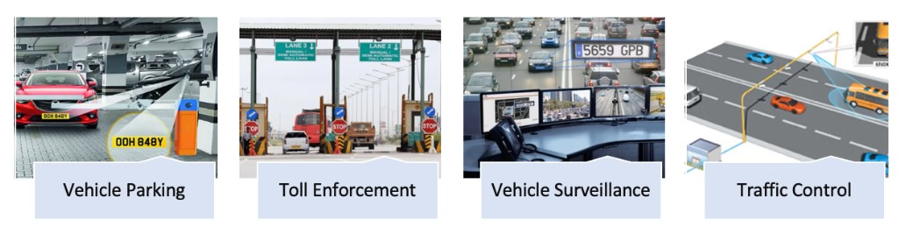

### Key Features:

### picture analysis, inclusive of segmentation, morphology, records, and dimension

### • picture enhancement, filtering, and deblurring

### • Geometric transformations and intensity-primarily based photo registration techniques

### • photograph transforms, such as FFT, DCT, Radon, and fan-beam projection

### • big image workflows, together with block processing, tiling, and multi resolution show

### • Visualization apps, which include picture Viewer and Video Viewer

### • Multi core and GPU-enabled functions, and C-code generation

### 2.1 Exploration and Discovery:

### photo Processing Toolbox helps pix and video generated through a wide variety of gadgets, together with webcams, virtual cameras, satellites and airborne sensors, medical imaging devices, microscopes, telescopes, and different scientific instruments. additionally these are features to visualise, examine, and method these photographs in lots of facts sorts.

### 2.2 preferred and specialized Vile codecs:

### It additionally helps the multiband picture formats BIP and BIL, as used by LANDSAT. Low-stage I/O und reminiscence mapping functions permit you to expand custom routines for working with any facts format.

### photo Processing Toolbox supports a number of specialized image document codecs. For scientific pictures, it supports DICOM documents, including related metadata.

### 2.2.3 picture Enhancement

### photo enhancement techniques in photograph Processing Toolbox enable to growth the sign-to-noise ratio and intensify image features by way of modifying the colors or intensities of an picture.

### The toolbox consists of specialised filtering routines and a generalized multidimensional filtering function that handles integer photo types, gives more than one boundary padding alternatives, and performs convolution and correlation.

### using predefined filters and features there's a possibility to

### • clear out with morphological operators

### • De-blur and sharpen

### • take away noise with linear, median, or adaptive filtering

### • carry out histogram equalization

### • Remap the dynamic range

### • alter the gamma value

### • modify comparison

### specialised filtering workouts and multi-dimensional filtering strategies also are gift. Predefined filters and also the functions for designing and enforcing the filters are gift.

### 2.2.four photograph De-blurring:

### image de-blurring algorithms additionally consist of blind, Lucy-Richardson, Wiener, and regularized filter de-convolution, as well as conversions among factor spread and optical transfer features

### these features assist accurate blurring caused by out-of-consciousness optics, motion by means of the camera or the issue during photo capture, atmospheric situations, brief exposure time, and other factors. All de-blurring functions paintings with multidimensional pics.

### 2.2.five image analysis:

### picture analysis is the system of extracting meaningful information from pix which include locating shapes, counting items, figuring out hues, or measuring object houses.

### picture Processing Toolbox presents a comprehensive suite of reference -wellknown algorithms and visualization features for image evaluation responsibilities which include statistical analysis,function extraction and property size.

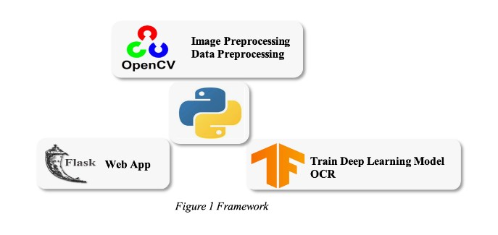

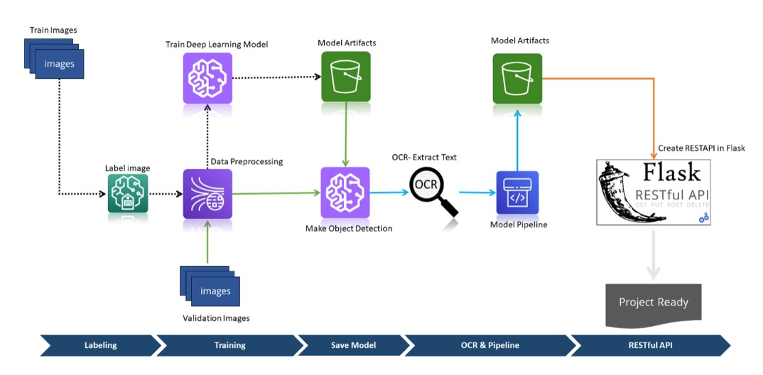

### 2.2.7 Device-Independent Color Management:

device-impartial color operation permits to at once constitute shade singly from enter and affair bias.

this is useful when analysing the traits of a tool, quantitatively measuring colour delicacy, or growing algorithms for numerous different bias. With specialised functions within the toolbox, you could convert snap shots between tool-independent shade spaces, similar as RGB, XYZ, L * a * b *, uvL and L * ch.

picture transformations

photograph related operations frequently endure the conversion among the statistics classes and photo kinds. There are one-of-a-kind kinds of pix supported through MATLAB

indexed photos

An indexed photo includes a data matrix, X, and a shade chart matrix, chart. Chart is an m- by using- 3array of class double containing floating- point values within the variety( zero, 1). each row of chart specifies the purple, green, and blue elements of a single coloration. An indexed photo uses" direct mapping" of pixel values to color chart values.

the relationship between the values in the photograph matrix and the color chart depends on the elegance of the imagematrix.but, the cost 1 points to the primary row in the shade chart, the value 2 factors to the change row, If the photograph matrix is of classdouble.however, there may be an offset- the price 0 points to the first row inside the color chart, the fee 1points to the trade row, If the photo matrix is of classuint8 or uint16. The neutralize is likewise used in plates educate formats to maximize the wide variety of colors that can be supported. inside the antedating picture, the picture matrix is of sophistication double.

intensity pictures

An depth image is a data matrix, whose values represent intensities inside some variety. An depth photo is represented as a unmarried matrix, with every detail of the matrix similar to one photo pixel. The matrix may be of class twice, uint8, or uintl6. even as intensity photos are from time to time saved with a colour chart, a shade chart continues to be used to show them. In substance, handles intensity snap shots are handled as indexed snap shots.

RGB( proper colour) pix

An RGB photo, now and again appertained to as a true color photo, is stored as an m- by using- n- by using- three records array that defines red, green, and blue colour factors for every person pixel. RGB pics do not use a palette. The coloration of each pixel is decided by the combination of the rod, inexperienced, and blue intensities stored in every shade aeroplane on the

pixel's function. images train formats store RGB pics as 24- bit pictures, in which the purple, inexperienced, and blue elements are 8 bits each. This yields a eventuality of 16 million colorations.

Statistical features

Statistical functions permit you to assay the overall traits of an image by way of

• Computing the imply or popular divagation

• displaying an picture histogram.

photograph Segmentation

photo segmentation is the procedure of dividing an picture into more than one corridor. that is normally used to perceive gadgets or other applicable information in virtual snap shots. there are numerous distinctive methods to carry out picture segmentation, together with

• Thresholding patterns comparable as Otsu's gadget

• shade- grounded segmentation comparable as okay- manner clustering

Template matching

All motorised street vehicles in India are tagged with a enrollment or license quantity. The automobile enrollment plate( normally known as wide variety plate) wide variety is issued by the quarter- position nearby shipping office( RTO) of separate countries — the principle authority on avenue matters. The range plates are located inside the front and reverse of the car. by law, all plates are needed to be in ultramodern Hindu- Arabic numbers with Latin letters. different hints consist of having the plate lit up at night time and the limit of the resources that might be used. In a few nations comparable as Sikkim, buses bearing outdoor plates are barred from coming into restricted regions. The transnational car enrollment regulation for India isIND.

example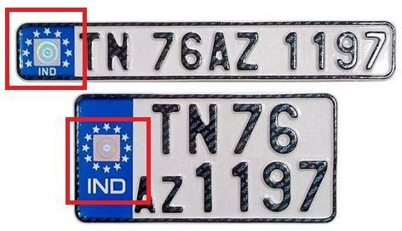

**Figure: 2.1 standard number plate for private vehicles**

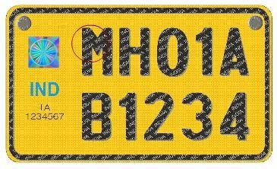

**Figure : 2.2 standard number plate for commercial vehicles**



**Figure :2.3 Standard Templates For Numeric Characters**

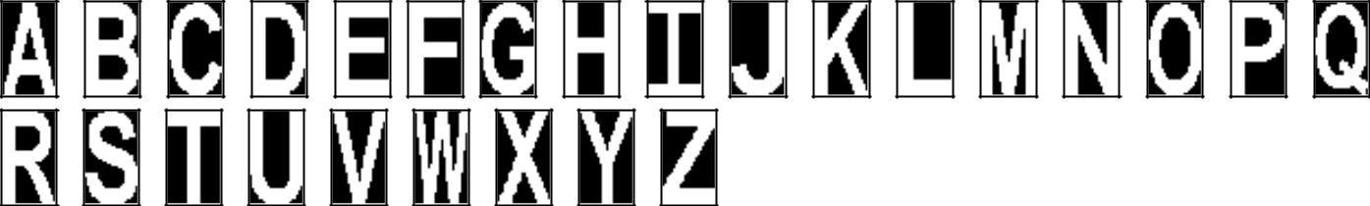

**Figure :2.4 Standard Templates For Alphabets**

# CHAPTER 3 ESTIMATION OF VELOCITY

## FRAMES TO VIDEO CONVERSION

The final RGB pix obtained after the entire shade picture processing are to be transformed into video. The very last video includes, most effective the detected object.

three.1 VELOCTTY ESTIMATION:

pace of the moving objects in a video may be decided using numerous strategies part-retaining varieties of model regularization, canny aspect detection in which difference among pics is considered to be the anticipated speed

in the early stages of prospect evaluation, an inexpensive c language speed estimate is regularly favored The Dix equation (Dix, 1952) analytically inverts root-mean-rectangular (RMS) pace for c programming language pace as a feature of time. further to many bodily shortcomings (assumption of a stratified (vz) earth), Dix inversion suffers from numerical troubles that cause bad speed estimates Dix inversion is risky when RMS velocities range hastily, and may produce c program languageperiod velocities with unreasonably large and speedy versions for this reason, the problem is regularly forged as a least-squares problem, which is regularized in time with a differential operator to penalize speedy velocity versions and to produce a clean end result.

(Clapp et al., 1998). while temporal speed smoothness may additionally often be justified from a geological factor of view, in a few cases however, it could trade all of sudden (e.g., carbonate layers, salt our bodies, strong faulting). In these situations the choice for a regularization method that yields clean velocities at the same time as preserving geologic interval pace sharp contrasts. similarly, no pre-defined barriers ought to be supplied.

on this venture, locating the velocity of the item by means of thinking about the maximum of mean of the difference of resultant pictures consistent with 2nd received after appearing aspect detection on them. among many part detectors, Canny edge detection approach is broadly taken into consideration to be an ideal detector Canny edge detector unearths edges by searching out neighborhood maxima of the gradient of optical photo I. The gradient is calculated the use of the derivative of a Gaussian filtert7] The approach makes use of two thresholds, to detect sturdy and weak edges, and includes the susceptible edges in the output most effective if they may be related to sturdy edges. This technique is therefore much less possibly than the others to be fooled via noise, and much more likely to locate authentic vulnerable edges.

Canny aspect detector is extensively considered as the suitable aspect detector [3]. this is justified by the inducement underlying the developing of the algorithm. the inducement for Cranny‟s aspect operator is to derive an „top-rated‟ operator in the sense that it

• Minimizes the opportunity of repeatedly detecting an part;

• Minimizes the chance of failing to stumble on an facet;

• Minimizes the space of the said aspect from the real part.

the first two of those criteria cope with the difficulty of detection, the 0.33 criterion addresses the problem of localization, that is, how correctly the position of an side is pronounced. The Canny area detector is based totally on computing the squared gradient

magnitude. The mathematics at the back of the complete optimization process is as an alternative complicated [9]. however, the greatest aspect detector turns cut to have a simple approximate implementation: edges are detected through smoothing the picture with a Gaussian low-bypass filter out and neighborhood maxima of the gradient magnitude that are above some threshold are then diagnosed as edges. The low-bypass filtering previous to calculating the gradients considerably contributes to reduction in noise sensitivity of the brink detector. the threshold nearby peak detection method is called non-maximum suppression, or NMS. The set of rules of canny aspect detection may be summarized as the subsequent steps of processing for a digital image I (x, y):

1. clean the photograph using a 2d Gaussian, Is=G*I

2. Compute the gradient and squared magnitude of the smoothed image

∇ Is= (∂Is/∂x, ∂Is/∂y)

M (x,y) = (∂Is/∂x)2 +( ∂Is/∂y)2

three. Use the unit vector ∇Ix/|∇Ix | (∂x,∂ y) at every point to estimate the gradient significance within the gradient direction and contrary of the gradient course. that is carried out by means of a weighted common of the neighbouring pixels within the course(∂x,∂y) or extra simply by deciding on the neighbouring pixel closest to the path (x+ ∂x, y+∂y).

4. permit p=m(x, y),p+ = m (x+ ∂x, y+∂y), and p_= m(x-∂x, y-∂y). define a top as ((p>p+)(p≥ p_))V((P>P_)(p≥ p+))

5. follow threshold to pick out strong peaks to be able to dispose of little peaks because of noise, etc.

using |∇Is| because the degree of side power, a hysteresis mechanism with two thresholds on edge strength, lo and hello, is then achieved to threshold out susceptible points but preserve susceptible points with related edges. In practice, the convolution with a - dimensional Gaussian in Step l is separated into two convolutions with one- dimensional Gaussians because of the rotationally symmetry property of Gaussian, this substantially reduces the implementation complexity. consequently, the first two steps of the algorithm may be carried out as:

(I) Create identity Gaussian mask G

(2) Convolve the photo I (x, y) with G along the rows to give the x thing image Ix, and down the columns to give the y element Iy.

(three) Create a identification masks for the primary by-product of the Gaussian inside the x and y instructions, ensuing in Gx and Gy

4) Convolve Ix with Gx to present Ixl, and convolve Iy with Gy to provide Iyl.

After performing edge detection at the photographs taken, the distinction in the resultant photographs is acquired which is considered in keeping with 2nd and the maximum of mean of the consequent is stated to be the speed of the required item. the velocity of moving

object in the frames is defined in pixels consistent with second. for this reason, speed of the item is decided the use of this technique.

# CHAPTER 4 FEASIBILITY OF PROJECT

## FEASIBILITY STUDY

all the initiatives can be feasible, if given limitless resources and endless time. but improvement of software is plagued via the shortage of assets and difficult shipping rates. it's miles both and prudent to assess the feasibility of the undertaking at the earliest feasible time.

four.

1. Key issues

3 key concerns are concerned in feasibility analysis.

4.1.1. financial Feasibility

It determines whether the undertaking goal may be within the aid limits allocated to it. It also determines whether it's far profitable to manner with the all venture or the advantage acquired from the brand new machine. All it calls for is a computer that may run MATLAB software. Now a day's computer systems aren't considered as financial difficulty. as a result this method is properly inside the budget of virtually all the humans

four.1.2. Technical Feasibility

Technical feasibility centres on the prevailing laptop system hardware, software and many others. And what quantity it may guide the proposed edition. Technical constraint is not serious constraint for feasibility of this technique.

This device is viable on the following grounds:

• All vital generation is available to people who need to expand an application.

• the prevailing resources are capable of conserving all of the vital in an efficient manner.

• The device is too flexible and can be improved in addition each time new modules are brought.

4.1.three. Operational Feasibility

This determines if the proposed machine has glad person goals and can be geared up into modern-day operation. The proposed will simply satisfy the user requirements and will also enhance their capability. it may be high-quality equipped into present day operations. additionally the maintenance of the machine could be very smooth and requires minimum attempt. consequently, the system is operationally possible.

4.2. **Feasibility observe of This assignment**

The requirements of engineering technique begins with feasibility study. The enter of the feasibility take a look at is an define description of the system. The result of feasibility examine is a report which recommends whether or not or no longer it's far well worth sporting on with requirements engineering and the machine development manner. carrying out the feasibility take a look at includes information evaluation, statistics collection and file writing.

This task requires a computer that may run the MATLAB software 2015 version and has the ability to upload the images from the digital cameras.

# CHAPTER 5

**SOFTWARE AND ITS SPECIFICATIONS**

## SOFTWAREREQUIREMENT SPECIFICATION

### INTRODUCTION

### The principle reason of this venture is to hit upon characters from registration code

### Image supplied by using a digicam. An green set of rules is advanced to hit upon a registration code in diverse luminance situations. This set of rules extracts the registration code facts from an photograph and offers it as an input to the stage of automobile license plate recognition. The photo of a vehicle is given as an input.

### Scope:

### The scope of this task is to come across the registration code from the given image and examine the output on MATLAB. This venture can work as a base for destiny enhancements inside the subject of photo processing, especially in registration code extraction and plate variety recognition.

### Developers Responsibilities:

The main responsibility lies in obtaining the result for input image which consists of different characters in license plate.

### General Description

* + 1. **Product Perspectives:**

For the given input image our project focuses mainly on applying morphological operations to increase the possibility of extracting the license plate region and to ease the segmentation process.

### Product Functions:

Steps involved in developing our project: The challenge starts with the literature study on morphological operations in picture processing

• Then an in depth observe on MATLAB is done

• The picture is examine using MATLAB

• Morphological processing is achieved.

• Segmentation of the required area is executed.

• Segmented photographs are used for template matching

• Extracted characters of the license plate are displayed

### User Characteristics:

Before implementing the assignment the user should have a basic idea in MATLAB software. person need no longer have the entire knowledge of the software program however he ought to recognise some of the image processing techniques in the software program. without having the primary understanding of the software program it's far hard to put in force the photo processing. which will analyse the mission, the person have to know the simple phrases like grey scale pix, pixel values regarding the photo processing.

In this project the user intervention is very less. The user just needs to provide the input video and run the code to see the output.

* 1. **Specific Requirements:**
     1. **Non-Functional Requirements:**

1. **Usability:**

The user can give a normal clarity image as input and can interpret output with minimum knowledge of basics.

### Performance:

The proposed system after giving the required input takes less time to process and produces output accurately.

### Supportability:

The system can be expanded further to add new factors that may effect. The proposed system can work under any environment without any problems.

### Design Requirements:

1. **HARDWARE REQUIREMENTS:**

Processor : Any Intel or AMD,1 GHz or faster processor RAM : 4GB

Hard disk : 1 TB

### Software requirements:

Operating system : Windows XP, WINDOWS 10 Language : MATLAB

### Introduction to MATLAB:

### MATLAB is a high-performance language for technical computing. It integrates computation visualization, and programming in an smooth-to-use surroundings wherein troubles and solutions are expressed in acquainted mathematical notation. traditional makes use of encompass:

### • Math and computation

### • set of rules improvement

### • Modelling, simulation, and prototyping

### • records analysis, exploration, and visualization

### • medical and engineering pics

### • application improvement, inclusive of graphical person interface building

### 

### MATLAB is an interactive device whose primary information detail is an array that doesn't require dimensioning. This permits you to remedy many technical computing problems, mainly those with matrix and vector formulations, in & fraction of the time.

### The call MATLAB stands for matrix laboratory, MATLAB functions a circle of relatives of packages answers known as toolboxes. Toolboxes are complete collections of MATLAB(M-files) that enlarge the MATLAB surroundings to clear up specific classes of problem.

### it's far the same old educational tool for introductory and advanced publications in mathematics, engineering, and science. MATLAB is the device of desire for high- productiveness research, improvement, and evaluation.

### MATLAB's aid for object-orientated programming includes classes, inheritance, digital dispatch, applications, pas-by-value semantics, and bypass-by way of-reference semantics. A wrappers function is created permitting MATLAB facts kinds to be passed and lower back.The MATLAB system:

The system mainly concentrates on

* Mathematics

Linear algebra, basic statistics, differentiation and integrals, Fourier transforms, and other mathematics

* Programming Scripts and Functions Program files, control flow, editing, debugging
* Data and File Management

Data import and export, workspace, files and folders The MATLAB system consists of these main parts:

### The MATLAB language:

### versions which include R2009, R2010, R2012, R2013, R2015,R2017 are to be had in each 'a' and 'b' versions. that is a high-level matrix/array language with manipulate glide statements, capabilities, information systems, enter/output, and object-orientated programming features. It allows both "programming inside the small" to swiftly create brief and dirty throw-away applications, and "programming in the massive" to create whole massive and complicated application packages.

### M-files:

* + 1. **M-file scripts:**

To resolve complicated troubles, typintegratedg all builtintegrated built-in an ASCI file named with .m extension can be done. it is called a script file or an M-report. In MATLAB, cd course can be used to exchange the built-ingintegrated and the built-instructionsintegrated built-in report might be completed. Pwd integrated MATLAB is used to see the presentintegrated built-ing built-in. The variable names and the names of MATLAB 7fd5144c552f19a3546408d3b9cfb251 capabilities are to be averted while built-in a filename for an M-document. MATLAB assist can be used to realize the builtintegrated of the built-in constructed functions.

### MATLAB program control:

MATLAB is also a programming language. Like different computer programming languages,

MATLAB has a few selection making structures for control of command execution. these decision making or manage glide systems encompass for loops, while loops, and if-else-stop constructions. manage go with the flow systems are often utilized in script M-files and function M files.

by way of growing a report with the extension .m, we will easily write and run programs. We do now not need to compile the program considering the fact that MATLAB is an interpretative (no longer compiled) language. MATLAB has hundreds of functions, and you can add your own the use of Mfiles. MATLAB gives numerous tools that may be used to govern the drift of a program.

### Types of Functions:

MATLAB offers several different types of functions to use in your programming.

### Anonymous Functions:

### An nameless function is a simple shape of the MATLAB feature that is defined within a single MATLAB statement. It consists of a single MATLAB expression and any wide variety of input and output arguments. you may define an nameless feature proper at the MATLAB command line, or within a feature or script. This gives you a quick means of creating easy features while not having to create a report for them each time.

### Primary and Sub functions:

Any function that isn't always anonymous should be defined inside a document. each such feature report consists of a required number one characteristic that looks first, and any quantity of sub capabilities that can observe the primary. primary functions have a wider scope than sub functions. that is, primary features can be referred to as from out of doors of the file that defines them (e.g., from the MATLAB command line or from features in other documents) even as sub features can't. Sub functions are seen only to the number one feature and different sub features within their own report.

### Plotting in MATLAB:

MATLAB affords an expansion of functions for displaying vector information as line features for annotating and that produce primary line plots. these capabilities fluctuate inside the way they scale the accepts input in the shape of vectors or matrices and routinely scales the axes to house the data. The mesh and surf commands create 3-D floor plots of matrix facts. floor object residences offer additional manipulate over the visible look of the floor and also the brink line styles, vertex markers, face colouring, lights, characteristics also can be particular.

### Data Types in MATLAB:

### with the aid of default, MATLAB stores most facts in arrays of sophistication double. The statistics in these arrays is saved as double precision (64-bit) floating-factor numbers. All MATLAB functions and abilities work with those arrays.

### For pix stored in one of the graphics record formats supported with the aid of MATLAB, but, this facts illustration isn't always usually ideal. The variety of pixels in such an image may be very huge; for example, a a thousand-by way of-1000 image has a million pixels. on account that each pixel is represented by using at the least one array element, this picture could require approximately 8 megabytes of reminiscence if it were stored as magnificence double. To lessen reminiscence necessities, MATLAB helps storing photo information in arrays of sophistication uint8 and uintl6. The statistics in these arrays is stored as eight-bit or sixteen-bit unsigned integers. these arrays require one-8th or one-fourth as a good deal memory as facts in double arrays.

### Implementation:

Implementation of registration code Detection set of rules the use of MATLAB. MATLAB is a totally effective software device used to enforce the responsibilities that require substantial computation. It presents smooth and quicker implementation of algorithms compared to C and C++. the key function in MATLAB is that it consists of a wealthy library capabilities for image processing and statistics evaluation. This makes MATLAB an excellent tool for faster implementation and verification of any algorithm before simply implementing it on a real hardware. on occasion, debugging of errors on actual hardware seems to be a completely painful undertaking. MATLAB provides an clean technique for de-bugging and correction of mistakes in any algorithm. other than this, MATLAB contains many features such as workspace, plot, imread, imhist, imshow, and many others. for facts evaluation and photo processing, which makes it a better choice over other software program languages like C and C++.thinking about the above blessings, we're p enforcing an set of rules for license plate Detection the use of MATLAB. The set of rules to begin with makes use of diverse inbuilt capabilities and makes use of few consumer defined routines related to photograph processing. as soon as the algorithm become advanced, it become confirmed with multiple enter images containing vehicle range plates. The input images contained number plates that had been aligned horizontally in addition to at some attitude from horizontal axis. once the set of rules was absolutely confirmed, the in-built features of MATLAB have been replaced through person described capabilities.

# CHAPTER 6 PROJECT IMPLEMENTATION

## PROJECT IMPLEMENTATION

### Image Acquisition:

The primary level of any vision machine is the photograph acquisition degree. After the picture has obtained, numerous methods of processing can be carried out to the photograph to perform the various extraordinary imaginative and prescient responsibilities required today. however, if the image has no longer been received satisfactorily then the intended responsibilities might not be manageable, despite the aid of some shape of photograph enhancement, image Acquisition enables you to gather snap shots and video from digital camera body grabbers directly into MATLAB and Simulink . you could locate hardware routinely and configure hardware residences. superior workflows can help you trigger acquisition at the same time as processing in-the-loop, perform background acquisition, and synchronize sampling throughout numerous multimodal gadgets. With assist for a couple of hardware carriers and industry requirements, you can use imaging devices ranging from cheaper. web cameras to high-stop medical and industrial devices that meet low-light, high-speed, and different difficult requirements. photograph received with the aid of digicam will be indicated in MATLAB as a matrix of zero's and 1's i.e, binary.

For this reason we can use following types of cameras

### CMOS Cameras:

CMOS (Complementary steel-Oxide Semiconductor) is a era used in fabricating integrated circuit chips. however within the context of pictures, it's far one of the alternative technologies used in virtual camera photograph sensors; the other being CCDs.

Early virtual cameras tended to use CCD sensors, as this changed into the extra mature generation. The evolution of CMOS sensors had a steeper gaining knowledge of curve, and at the start their use was constrained to lower-price merchandise where image exceptional become no longer an overriding situation. Canon and Sony subtle CMOS sensors thru numerous generations, today (2011) while evaluating sensors of identical length, CMOS sensors commonly exceed CCDs in photograph first-rate measures. typically a CMOS design uses energetic circuitry located on directly on the chip itself that can speed photograph readout and help with noise discount. The brought circuit complexity does increase the up- front costs to the chip developer, hence we see sensor producer. Sony looking to recoup a number of those charges by way of promoting sensor chips to its nominal competitors within the digicam marketplace: Pentax, Nikon, Leica, and so forth.

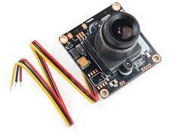

Figure:6.1CMOS Camera

### CCD Cameras:

A fee-Coupled device (CCD) is a tool for the movement of electrical charge, normally from inside the tool to an area in which the charge may be manipulated, for instance conversion into a digital price. this is finished by "moving" the signals between levels within the tool separately. CCDs pass charge between capacitive containers in the device, with the shift taking into consideration the switch of charge among boxes.

The CCD is a first-rate piece of era in digital imaging. In a CCD image sensor, pixels are represented with the aid of p-doped MOS capacitors. these capacitors are biased above the threshold for inversion while image acquisition begins, permitting the conversion of incoming photons into electron prices at the semiconductor-oxide interface; the CCD is then used to read out those costs. although CCDs aren't the handiest era to permit for mild detection, CCD picture sensors are widely utilized in professional, medical, and clinical programs in which 86f68e4d402306ad3cd330d005134dac photograph data is needed. In programs with less exacting exceptional needs, such as consumer and professional digital cameras, lively pixel sensors (CMOS) are typically used; the large pleasant gain CCDs loved early on has narrowed over the years.

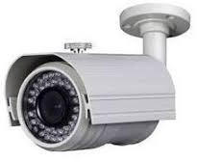

Figure:6.2 CCD Cameras

### Infrared Cameras:

Infrared (IR) mild is electromagnetic radiation with longer wavelengths than those of visible light, extending from the nominal crimson edge of the seen spectrum at 500 nanometres (nm) to1 mm. This range of wavelengths corresponds to a frequency variety of approximately530 THz down to three hundred GHz. most of the thermal radiation emitted by means of gadgets near room temperature is infrared.

Infrared mild is emitted or absorbed by using molecules when they change their rotational- vibrational actions. Infrared energy elicits vibrational modes in a molecule thru a alternate inside the dipole moment, making it a useful frequency variety for take a look at of these energy states for molecules of the proper symmetry. Infrared spectroscopy examines absorption and transmission of photons in the infrared energy variety.

Infrared mild is used in industrial, scientific, and scientific programs. night time-imaginative and prescient gadgets the usage of energetic close to-infrared illumination permit humans or animals to be located without the observer being detected. Infrared astronomy uses sensor-prepared telescopes to penetrate dusty regions of area, including molecular clouds; come across gadgets consisting of planets, and to view tremendously pink-shifted gadgets from the early days of the universe. Infrared thermal-imaging cameras are used to come across heat loss in insulated systems, to study converting blood flow in the skin, and to discover overheating of electrical apparatus.

primarily based on our utility any of the above digicam can be used. here in this mission we use photographs taken by means of a CMOS camera.

below figures shows the one of the pictures we use for the project and how the MATLAB reads the picture.

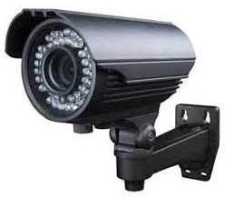

Figure:6.3 IR Cameras

### License Plate Extraction:

Localization of capability license plate regions from automobile images is a tough challenge due to large versions in size, form, coloration, texture and spatial orientations of license plate regions in such snap shots. In standard, goal of any computerized registration code reputation (ALPR) gadget is to localize potential license plate vicinity(s) from the vehicle pix captured thru a street-aspect camera and interpret them the use of template matching technique to get the license quantity of the car. In a web ALPR machine, the localization and interpretation of license plates take area instantaneously from the incoming still frames, enabling real-time tracking of moving cars through the surveillance camera. An offline ALPR machine, in contrast, captures the vehicle photographs and shops them in a centralized statistics server for further processing, i.e. for interpretation of car license plates.

### Pre processing techniques:

* + - 1. **Reduction of colors:**

A problem arises while processing image is that color can appear in a different way in distinct lightning situations. to overcome this we lessen the number of colors around 50. Following can be reasons for colour reduction:

• snap shots with more than 256 shades will want to be dithered or mapped and, consequently, might not display properly.

• photo has extra than 256 colors, MATLAB can not shop the picture statistics in a uint8 array but typically uses an array of class double alternatively, and making the garage size of the photograph an awful lot larger (each pixel makes use of sixty four bits).

### Gray scale conversion:

From the 24-bit color value of each pixel (i, j) the R, G and B components are separated and the8-bit Gray value is calculated using the formula:

Gray(i, j) = 0.59 * R(i, j) + 0. 30 G(i, j) +0.11 * B(i, j) (1)

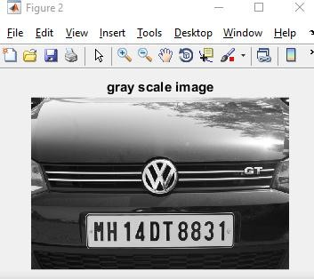

### Figure:6.4Gray Scale Image

* 1. **Dilation:**

Dilation allows objects to expand thereby further highlighting shapes/geometry of objects in an image. Structuring element is simply a matrix of 0s and 1s that could be of any arbitrary shape and size.

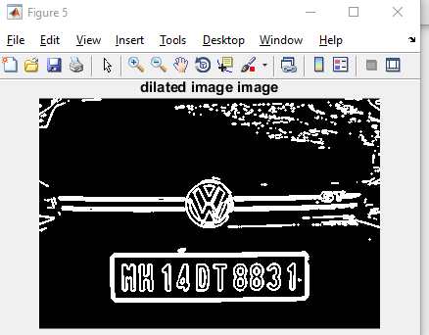

### Figure:6.5 Dilated image

* 1. **Filling:**

Dilated image is filled with 'holes' to emphasize region of interest. Following examples shows images before dilate and erode operation

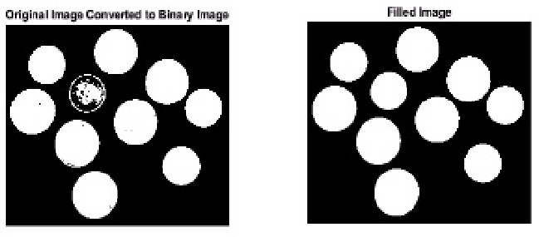

### Figure:6.6 image filling

* 1. **Edge Detection:**

On this paintings, we've extracted the edges created by means of the characters in the license plate. it's miles seen that once the characters of the license range are written horizontally the vertical edges of each man or woman appear at everyday c language and that they have a specific top. The sample and awareness of the vertical edges additionally stays in conformity with the sample of the license wide variety. This look of vertical side pattern is statistically visible to occur within the registration code, nowhere else within the herbal scene of the image. The area of the place have to not be much less than special threshold values. duration and Breadth or element ratio should lie inside 10:1.

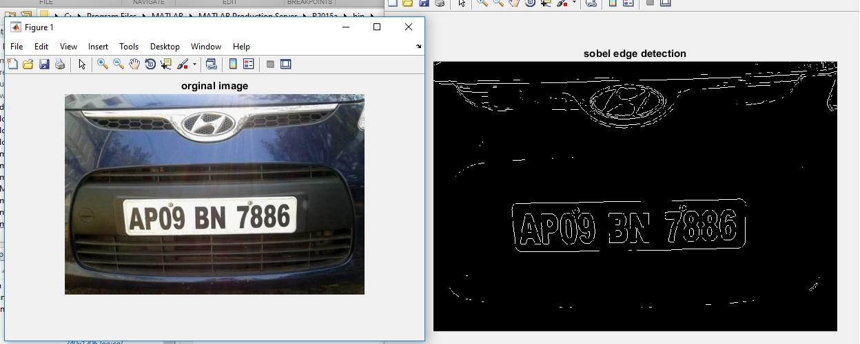

**Figure:6.7 Edge Detection Example**

**Normalization and contrast enhancement:**

* + 1. **Median filtering**

Median filter is a non-linear clear out, which replaces the gray fee of a pixel with the aid of the median of the gray values of its neighbours. we've got used 3x3 masks to get eight neighbours of a pixel and their corresponding grey values. This operation eliminates salt-and-pepper noise from the photo.

### Contrast enhancement:

### assessment of each photograph is better via histogram equalization technique, overall 256 numbers of grey ranges (from zero to 255) are used for stretching the contrast. allow overall number of pixels in the photograph be N and the number of pixels having gray degree ok be nk. Then the possibility of occurrence of grey stage okay is, Pk= nk/N. The stretched gray stage Sk is calculated using the cumulative frequency of incidence of the gray level okay.

### Segmentation:

1. Image segmentation is the process of partitioning an image into parts or regions. This division into parts is often based on the characteristics of the pixels in the image. For example, one way to find regions in an image is to look for abrupt discontinuities in pixel values, which typically indicate edges. These edges can define regions. Another method is to divide the image into regions based on color values. Segmentation is done using blob analysis which involves following commands. 'Bwlabel' command labels and gives you the number of pixels connected together in a sequence to form a group of connected objects. “regionprops” measures a set of properties for each connected component. Regionprops computes only the 'Area', 'Centroid', and
2. „Bounding Box‟ measurements. Usage of both of these commands to label objects is used in rectangle as Bounding Box around the objects. Boundaries of each labelled objects and using these boundary coordinates cropped the characters from the license plate. At this stage, cropped character may also contain garbage objects as well as useful LP characters and numbers; few of the extracted objects.

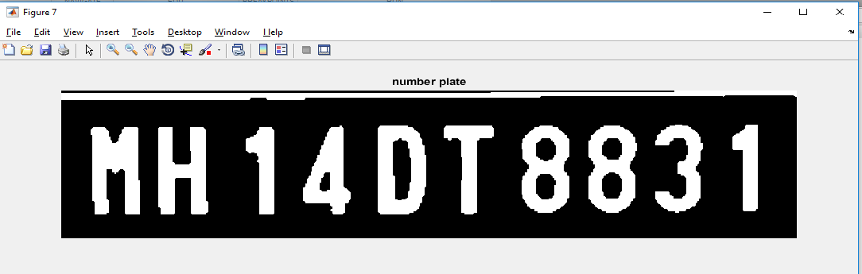

**Figure:6.8 Segmented Number Plate**

* 1. **Commands used in segmentation:**

**Imshow:**

**Syntax:**

1. **imshow(1):** displays the image I in a figure, where I is a gray scale, RGB (true color), or binary image. For binary images, imshow displays pixels with the value 0 (zero) as black and 1 as white.
2. **imshow(filename):** displays the image stored in the graphics file filename. The file must be in the current directory imread or dicomread. imshow calls imread or dicomread to read the image from the file, but does not store the image data in the MATLAB workspace. If the file contains multiple images, imshow displays only the first one

### Imdilate():

Syntax:

1. **IM2 =imdilate (IM, SE** ) dilates the gray scale, binary, or packed binary image IM, returning the dilated image, IM2. The argument SE is a structuring element object, or array of structuring element objects, returned by the strel function. If IM is logical and the structuring element is flat, **imdilate** performs binary dilation; otherwise, it performs gray scale dilation. If SE is an array of structuring element objects, imdilate performs multiple dilations of the input image, using each structuring element in SE in succession.
2. **IM2= imdilate(IM, NHOOD)** dilates the image IM, where NHOOD is a matrix of 0's and1's that specifies the structuring element neighbourhood. This is equivalent to the syntax **imdilate (IM, strel (NHOOD)).** The imdilate function determines the centre element of the neighbourhood by **floor ((size (NHOOD)+1)/2)).**

### Imfill():

Syntax:

1.**BW2 = imfill(BW)** displays the binary image BW on the screen and lets you define the region to fill by selecting points interactively by using the mouse. To use this interactive syntax, BW must be a 2-D image. Press Backspace or Delete to remove the previously selected point. A shift-click, right-click, or double-click selects a final point and starts the fill operation. Pressing Return finishes the selection without adding a point.

1. **BW2= imfill(BW, 'holes')** fills holes in the binary image BW. A hole background pixels that cannot be reached by filling in the background from the edge of the image.

### Imerode():

Syntax:

**1.** IM2= imerode(IM,SE) erodes the gray scale, binary, or packed binary photograph IM, returning the eroded image IM2. The argument SE is a structuring detail object or array of structuring detail items back by the strel function. If IM is logical and the structuring detail is flat, imerode plays binary erosion; in any other case it plays grey scale erosion. If SE is an array of structuring detail gadgets, imerode plays multiple erosions of the enter photograph, the use of each structuring detail in SE in succession.

four. regionprops():

Syntax:

1. STATS= regionprops(L, houses) measures a set of residences for every labelled area within the label matrix L. high-quality integer factors of L correspond to exceptional regions. as an example, the set of factors of L same to at least one corresponds to location 1; the set of factors of L same to two corresponds to location 2; and so forth.

2. STATS = regionprops(BW, residences) measures a set of properties for every connected component (item) within the binary photograph, BW. The image BW is a logical array; it could have any size.

**Results:**

# RESULTS

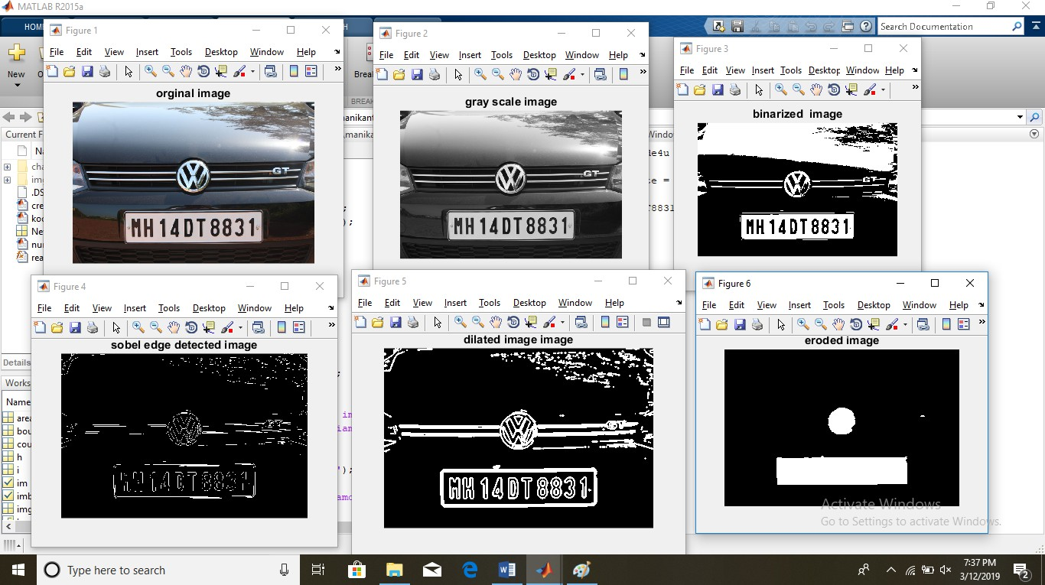

**Figure:7.1 Different stages in number plate extraction**

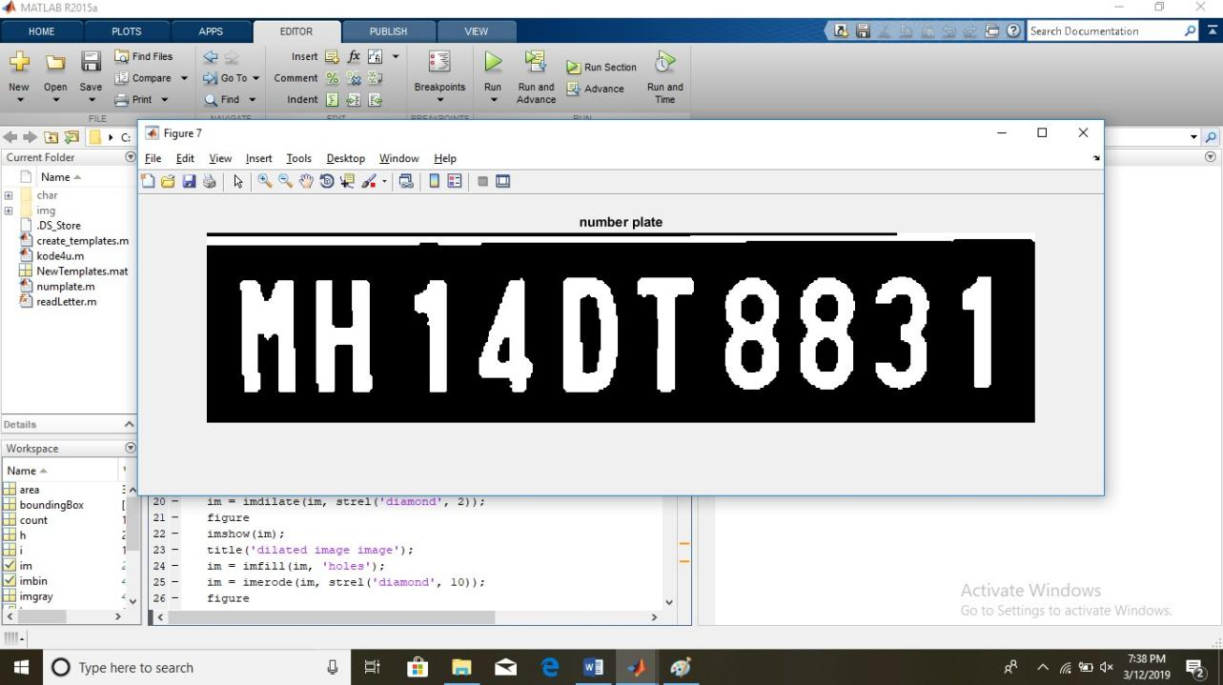

**Figure: 7.2 Segmented Number Plate**

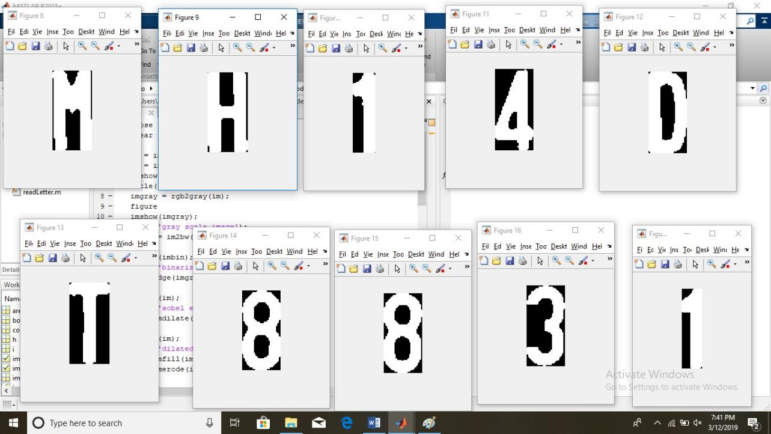

**Figure: 7.3 Segmented Characters**

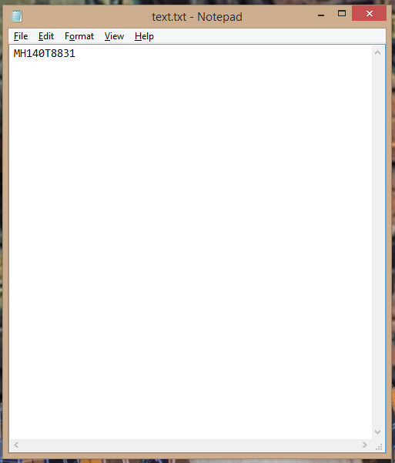

**Figure:7.4 Text Converted Number Plate**

First we have done our application in MATLAB then command window seems.

• Then consumer enters the document name inside the format of "document name jpg".

• Then need to specify our requirement whether to display every stage output or best very last output by means of either entering (y or n).

• As soon as we pick out our requirement the program imports the photo and program plays processing operations according to program.

• masking and localization of plate are performed in keeping with targeted threshold values.

• The characters inside the localized plate are cropped and segmented and segmented outputs are displayed in discern window.

• The number extracted from the variety plate is saved in a textual content record for the future use.

### CONCLUSION:

* + - Our work mainly proposes a plate localization and extraction technique from vehicle number plates.
    - Firstly extraction of plate location, then separation of the plate characters individually by performing different pre-image processing techniques and segmentation, finally the segmented numbers is correlated with the standard templates in the library.
    - In order to extract the plate location a bounding box method is used. And also each character is also segmented using the same bounding box method.
    - The Segmented characters are identified by using Template Matching Method.
    - The suggested method is tested with various types of vehicles like four wheelers and with yellow and white background.
    - The number plates with additional unnecessary data are also segmented with great accuracy.

### FUTURE SCOPE:

• The future work will involve in recognizing the individual characters from the plate with other colours back grounds with the standard templates issued by the government.

• This mainly uses in high traffic areas to control the traffic without help of Human.

• It can be used for the monitoring Parking Areas.

• In order to punish the one who violates the traffic rules such as crossing the speed limits, signal jumping and unauthorised vehicles.

52